Lesson 2.12:

HTML Structure Part 2
Congratulations! You created your first HTML elements, set up your development environment, streamlined your workflow, and even organized elements on a page using a standard HTML tree structure.
Now, let's take a moment for a little trip down memory lane. Remember this clip from the beginning of the lesson?
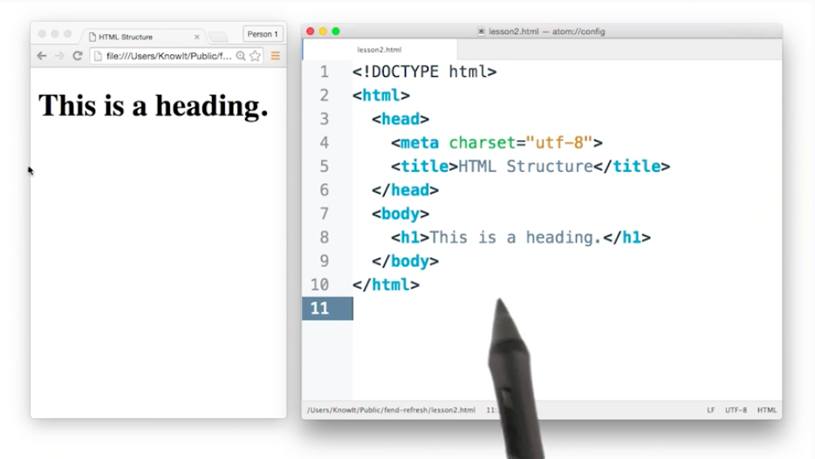

Did it seem odd that it took 10 lines of HTML to create a webpage that only displayed four words? At this point, you know that <h1>This is a heading.</h1> is responsible for displaying the heading on the page, but what about the rest of the code?

The HTML Document
Every HTML document you create or load is derived from this basic format:
You can think of it as a template. And, following this template will help ensure that the page is displayed as the developer (you) intended. It not only says what should be displayed, but also includes relevant information that tells the browser how to display it.
This template can be broken down into 3 parts:
- DOCTYPE: Describes the type of HTML. While there are technically different types, for 99.999% of the HTML you'll write, you’ll likely be fine with <!DOCTYPE html>.
- <head>: Describes meta information about the site, such as the title, and provides links to scripts and stylesheets the site needs to render and behave correctly.
- <body>: Describes the actual content of the site that users will see.
Omitting some of this information doesn't necessarily mean that the page won't be displayed. In fact, your browser will assume certain parts of the template exist even if you accidentally leave them out. Take this line of HTML for example:
<h1>This is a heading</h1>
If you create an HTML file with only this line, open the file in any modern browser, and inspect the page with developer tools, you’ll see that certain parts of the basic HTML document format were assumed:
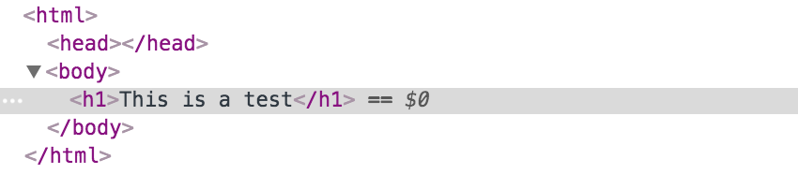
The view from the Elements panel in Developer Tools when you omit all but <h1>...</h1>. (Notice that an empty <head> has been created for you.)
That being said, this is not guaranteed behavior. Older browsers can be unpredictable, and you won’t know what browser your visitors will decide to use. It’s good practice to include all the basic parts of the template so that you aren’t relying on the guesswork of browsers to display your sites correctly.

Lesson 2.13:

HTML Doctypes
An HTML document will usually start with a type declaration (which is not a tag, so it should not have a closing tag). The declaration helps the browser determine what type of HTML document it’s trying to parse and display.
If you’ve ever looked at an older website using dev tools, you might have noticed a doctype that looks like this:
<!DOCTYPE HTML PUBLIC "-//W3C//DTD HTML 4.01//EN" "http://www.w3.org/TR/html4/strict.dtd">
(Triggers Standards mode but specifies an older form of validation.)
Or maybe you didn’t see a doctype at all?
<html>
…
</html>
(Triggers “Quirks” mode. This is bad.)
But newer websites (and your websites!) will have a declaration that looks like this:
<!DOCTYPE html>
(Triggers Standards mode with all updated features.) 😊
Browsers look for this doctype declaration to determine which rendering mode to use to render the site. Generally, newer sites follow standard HTML specifications. The current standard HTML specification is called HTML5 (which is what you're learning!). On the other hand, older sites, created before HTML standards really existed, might use a different rendering mode that imitates the behavior of older browsers.
If you are interested in reading more about doctype declarations and different rendering modes, you can read about them here.
Once you’ve declared the doctype, the next part of your HTML document is the <html> tag, which tells the browser that everything enclosed inside the <html> ... </html> should be parsed as HTML. Then you have the two main sections of your HTML document: <head>and <body>
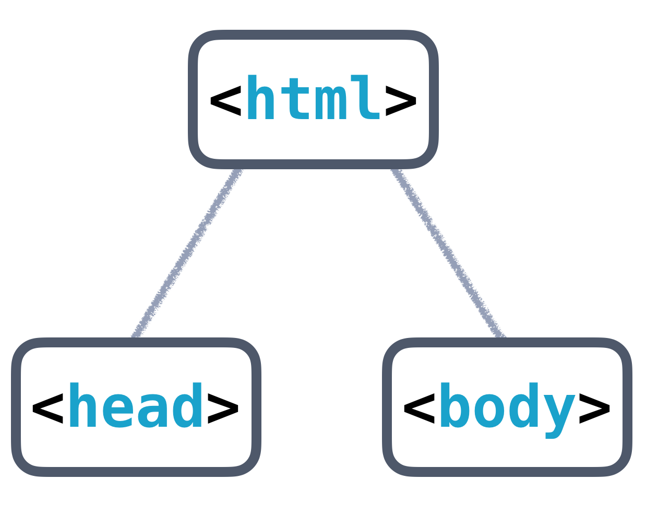
Basic HTML Tree Structure

<head> and <body>
The <head> will contain general information and metadata about the page, while the <body> will contain the content that will be displayed on the page. Here’s an example tree structure for a full HTML document:
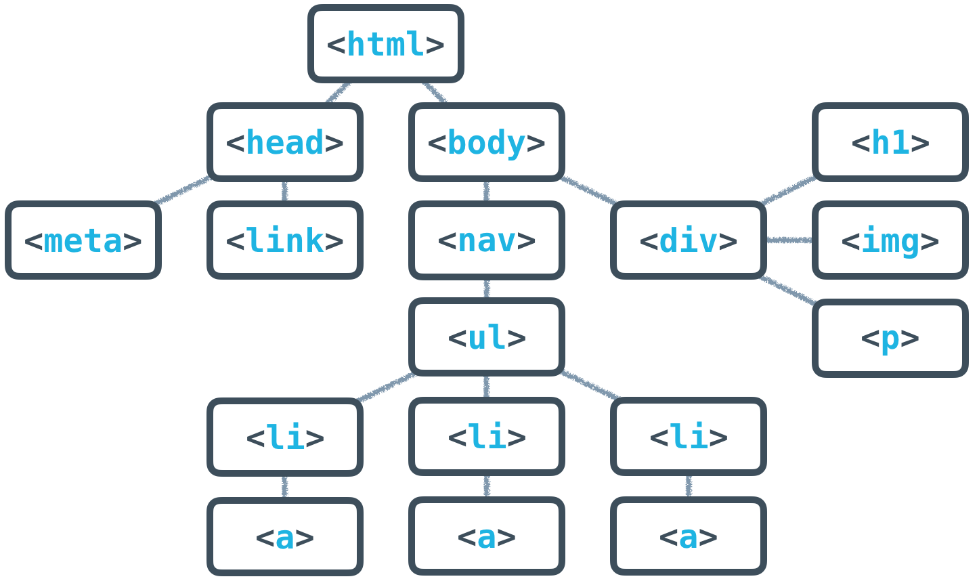
Full HTML Tree Structure
All of the HTML syntax that you’ve learned in this lesson will help you create the content of the page, which is always contained inside the <body> tags. The <body> is always visible.
The <head>, on the other hand, is never visible, but the information in it describes the page and links to other files the browser needs to render the website correctly. For instance, the <head> is responsible for:
- the document’s title (the text that shows up in browser tabs): <title>About Me</title>.
- associated CSS files (for style): <link rel="stylesheet" type="text/css" href="style.css">.
- associated JavaScript files (multipurpose scripts to change rendering and behavior): <script src="animations.js"></script>.
- the charset being used (the text's encoding): <meta charset="utf-8">.
- keywords, authors, and descriptions (often useful for SEO): <meta name="description" content="This is what my website is all about!">.
- … and more!
At this point, just focus on these two tags:
- <title>About Me</title>
- <meta charset="utf-8">
<meta charset="utf-8"> is pretty standard, and will allow your website to display any Unicode character. (Read more on how UTF-8 works here.) <title> will define the title of the document and will be displayed in the tab of the browser window when a user visits the page.
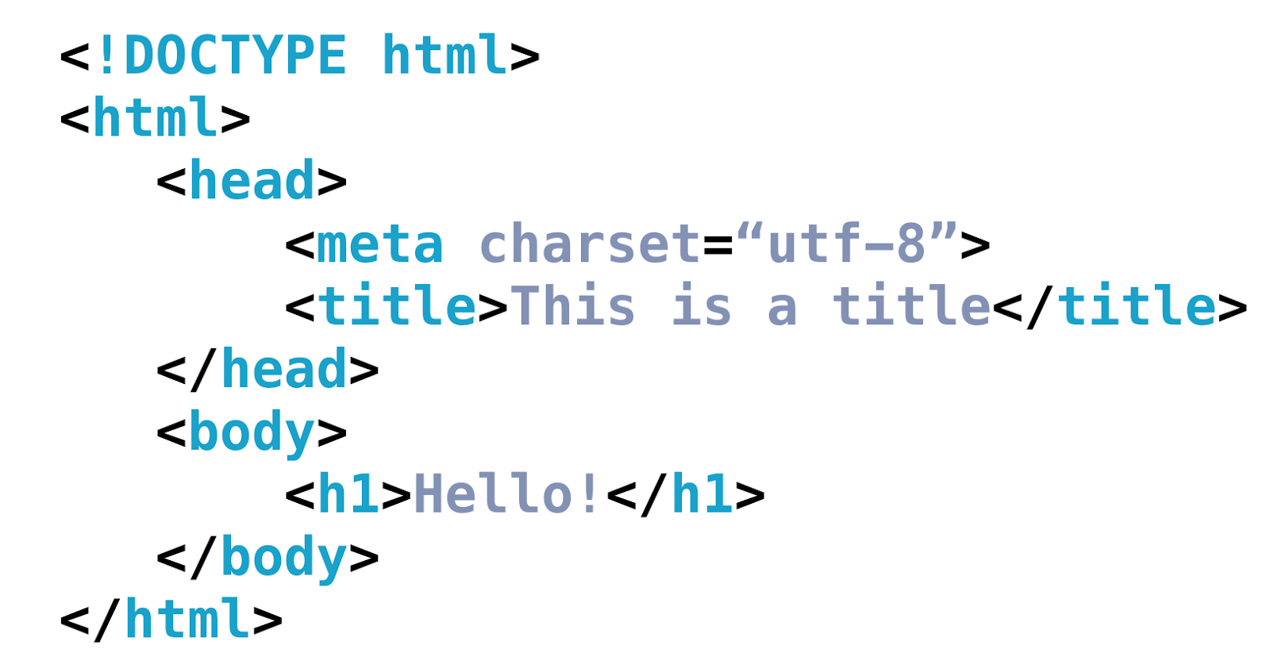
Full HTML Template

HTML Validators
This might seem like a lot to remember, but thankfully, there are tools out there to help you. Much like how the Udacity Feedback Extension tells you when you've met all the requirements for a particular project, HTML validators analyze your website and verify that you're writing valid HTML.

HTML Comments <!-- This is a comment -->

CSS Comments /* This is a comment */

Writing Selectors

Here's the complete solution:

<!DOCTYPE html>
<html>
<head>
<title>Writing Selectors Quiz</title>
<style>
#menu {
text-align: center;
}
.item {
color: red;
}
.picture {
border-radius: 5px;
}
.description {
font-style: italic;
}
</style>
</head>
<body>
<div id="menu">
<h1 class="item">Chicken Clay Pot</h1>
<img src="img/clay-pot.jpg" alt="clay pot" class="picture">
<p class="description">Crispy rice baked in clay pot topped with chicken and vegetables</p>
</div>
</body>
</html>

If you analyze the HTML, you should be able to tell that this webpage is a menu (or the beginnings of one 😎). The div element represents the menu, and inside the menu you see an item, picture, and description.

<div id="menu">
<h1 class="item">Chicken Clay Pot</h1>
<img src="img/clay-pot.jpg" alt="clay pot" class="picture">
<p class="description">Crispy rice baked in clay pot topped with chicken and vegetables</p>
</div>

To style this, I added the missing selectors to the CSS.

# menu {
text-align: center;
}
.item {
color: red;
}
.picture {
border-radius: 5px;
}
.description {
font-style: italic;
}

Notice how the first selector uses a # sign, but the other three selectors use a .

That's because menu is an id attribute and item, picture, and description are class attributes.

As you continue through this nanodegree, remember that id selectors always begin with the pound/hashtag symbol followed by the id name and class selectors always begin with the dot/period symbol followed by the class name.

This is how the answer looks in the browser:

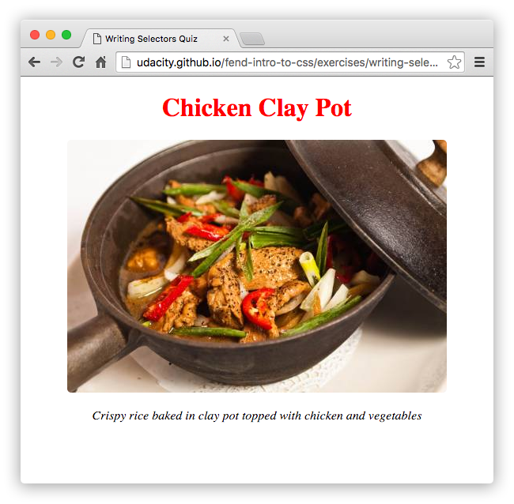

Lesson 6.9:

How to Link to a Stylesheet
Before your webpage can use the stylesheet, you need to link to it. To do this, you'll need to create a <link> to your stylesheet in your HTML. To create a link, simply type the following inside the <head> of your HTML.
<link href="path-to-stylesheet/stylesheet.css" rel="stylesheet">
The href attribute specifies the path to the linked resource (you can link to other resources besides stylesheets, more on this later) and the rel attribute names the relationship between the resource and your document. In this case, the relationship is a stylesheet. When you're done, it will look something like this...
<head>
<title>My Webpage</title>
<!-- ... -->
<link href="path-to-stylesheet/stylesheet.css" rel="stylesheet">
<!-- ... -->
</head>

Lesson 10

TIP: HTML and CSS are markup languages. Markup languages are used to describe and define elements within a document. JavaScript is a programming language. Programming languages are used to communicate instructions to a machine. Programming languages can be used to control the behavior of a machine and to express algorithms.
Lesson 11:

Escaping characters
In JavaScript, you use the backslash to escape other characters.
Escaping a character tells JavaScript to ignore the character's special meaning and just use the literal value of the character. This is helpful for characters that have special meanings like in our previous example with quotes "…".
Because quotes are used to signify the beginning and end of a string, you can use the backslash character to escape the quotes in order to access the literal quote character.
"The man whispered, \"please speak to me.\""

Special characters
Quotes aren’t the only special characters that need to be escaped, there’s actually quite a few. However, to keep it simple, here’s a list of some common special characters in JavaScript.
Code | Character
\\ | \ (backslash)
\" | '' (double quote)
\' | ' (single quote)
\n | newline
\t | tab
https://www.ascii-code.com/
Lesson 12

If...else statements
If...else statements allow you to execute certain pieces of code based on a condition, or set of conditions, being met.
if (/* this expression is true */) {
// run this code
} else {
// run this code
}
This is extremely helpful because it allows you to choose which piece of code you want to run based on the result of an expression. For example,
var a = 1;
var b = 2;
if (a > b) {
console.log("a is greater than b");
} else {
console.log("a is less than or equal to b");
}
Prints: "a is less than or equal to b"
A couple of important things to notice about if...else statements.
The value inside the if statement is always converted to true or false. Depending on the value, the code inside the ifstatement is run or the code inside the else statement is run, but not both. The code inside the if and else statements are surrounded by curly braces {...} to separate the conditions and indicate which code should be run.
TIP: When coding, sometimes you may only want to use an if statement. However, if you try to use only an elsestatement, then you will receive the error SyntaxError: Unexpected token else. You’ll see this error because elsestatements need an if statement in order to work. You can’t have an else statement without first having an ifstatement.

Logical Operators
Here’s the logical expression used to represent Julia’s weekend plans:
var colt = "not busy";
var weather = "nice";
if (colt === "not busy" && weather === "nice") {
console.log("go to the park");
}
Prints: "go to the park"
Notice the && in the code above.
The && symbol is the logical AND operator, and it is used to combine two logical expressions into one larger logical expression. If both smaller expressions are true, then the entire expression evaluates to true. If either one of the smaller expressions is false, then the whole logical expression is false.
Another way to think about it is when the && operator is placed between the two statements, the code literally reads, "if Colt is not busy AND the weather is nice, then go to the park".

Logical expressions
Logical expressions are similar to mathematical expressions, except logical expressions evaluate to either true or false.
11 != 12
Returns: true
You’ve already seen logical expressions when you write comparisons. A comparison is just a simple logical expression.
Similar to mathematical expressions that use +, -, *, / and %, there are logical operators &&, || and ! that you can use to create more complex logical expressions.

Logical operators
Logical operators can be used in conjunction with boolean values (true and false) to create complex logical expressions.
By combining two boolean values together with a logical operator, you create a logical expression that returns another boolean value. Here’s a table describing the different logical operators:

Operator | Meaning | Example | How it works
&& | Logical AND | value1 && value2 | Returns true if both value1 and value2 evaluate to true.
|| | Logical OR | value1 || value2 | Returns true if either value1 or value2 (or even both!) evaluates to true.
! | Logical NOT | !value1 | Returns the opposite of value1. If value1 is true, then !value1 is false.

Before you advance any further in the lesson, here’s the truth tables for logical AND ( && ) and logical OR ( || ).

&& (AND)
A | B | A && B
true | true | true
true | false | false
false | true | false
false | false | false

|| (OR)
A | B | A || B
true | true | true
true | false | true
false | true | true
false | false | false
Truth tables are used to represent the result of all the possible combinations of inputs in a logical expression. Arepresents the boolean value on the left-side of the expression and B represents the boolean value on the right-side of the expression.
Truth tables can be helpful for visualizing the different outcomes from a logical expression. However, do you notice anything peculiar about the truth tables for logical AND and OR?

Short-circuiting
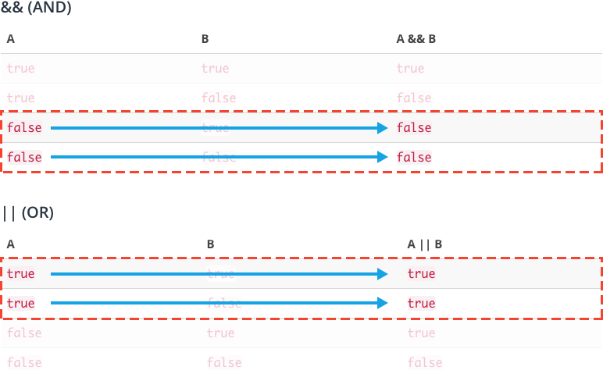
In some scenarios, the value of B in logical AND and OR doesn't matter.
In both tables, there are specific scenarios where regardless of the value of B, the value of A is enough to satisfy the condition.
For example, if you look at A AND B, if A is false, then regardless of the value B, the total expression will always evaluate to false because both A and B must be true in order for the entire expression to be true.
This behavior is called short-circuiting because it describes the event when later arguments in a logical expression are not considered because the first argument already satisfies the condition.
12-16

Truthy and Falsy
Every value in JavaScript has an inherent boolean value. When that value is evaluated in the context of a boolean expression, the value will be transformed into that inherent boolean value.
The paragraph above is pretty dense with information. You should probably re-read it again! ☝️

Falsy values
A value is falsy if it converts to false when evaluated in a boolean context. For example, an empty String "" is falsy because, "" evaluates to false. You already know if...else statements, so let's use them to test the truthy-ness of "".
if ("") {
console.log("the value is truthy");
} else {
console.log("the value is falsy");
}
Returns: "the value is falsy"

Here’s the list of all of the falsy values:
- the Boolean value false
- the null type
- the undefined type
- the number 0
- the empty string ""
- the odd value NaN (stands for "not a number", check out the NaN MDN article)
That's right, there are only six falsy values in all of JavaScript!

Truthy values
A value is truthy if it converts to true when evaluated in a boolean context. For example, the number 1 is truthy because, 1 evaluates to true. Let's use an if...else statement again to test this out:
if (1) {
console.log("the value is truthy");
} else {
console.log("the value is falsy");
}
Returns: "the value is truthy"
Here are some other examples of truthy values:
true
42
"pizza"
"0"
"null"
"undefined"
{}
[]

Declaring dFunctions

How to declare a function
Functions allow you to package up lines of code that you can use (and often reuse) in your programs.
Sometimes they take parameters like the pizza button from the beginning of this lesson. reheatPizza() had one parameter: the number of slices.
function reheatPizza(numSlices) {
// code that figures out reheat settings!
}
The reverseString() function that you saw also had one parameter: the string to be reversed.
function reverseString(reverseMe) {
// code to reverse a string!
}
In both cases, the parameter is listed as a variable after the function name, inside the parentheses. And, if there were multiple parameters, you would just separate them with commas.
function doubleGreeting(name, otherName) {
// code to greet two people!
}
But, you can also have functions that don't have any parameters. Instead, they just package up some code and perform some task. In this case, you would just leave the parentheses empty. Take this one for example. Here's a simple function that just prints out "Hello!".
// accepts no parameters! parentheses are empty
function sayHello() {
var message = "Hello!"
console.log(message);
}
If you tried pasting any of the functions above into the JavaScript console, you probably didn't notice much happen. In fact, you probably saw undefined returned back to you. undefined is the default return value on the console when nothing is explicitly returned using the special return keyword.

Return statements
In the sayHello() function above, a value is printed to the console with console.log, but not explicitly returned with a return statement. You can write a return statement by using the return keyword followed by the expression or value that you want to return.
// declares the sayHello function
function sayHello() {
var message = "Hello!"
return message; // returns value instead of printing it
}

How to run a function
Now, to get your function to do something, you have to invoke or call the function using the function name, followed by parentheses with any arguments that are passed into it. Functions are like machines. You can build the machine, but it won't do anything unless you also turn it on. Here's how you would call the sayHello() function from before, and then use the return value to print to the console:
// declares the sayHello function
function sayHello() {
var message = "Hello!"
return message; // returns value instead of printing it
}
// function returns "Hello!" and console.log prints the return value
console.log(sayHello());
Prints: "Hello!"

Parameters vs. Arguments
At first, it can be a bit tricky to know when something is either a parameter or an argument. The key difference is in where they show up in the code. A parameter is always going to be a variable name and appears in the function declaration. On the other hand, an argument is always going to be a value (i.e. any of the JavaScript data types - a number, a string, a boolean, etc.) and will always appear in the code when the function is called or invoked.

Lesson 12: 19 - Switch Statement

If you find yourself repeating else if statements in your code, where each condition is based on the same value, then it might be time to use a switch statement.
if (option === 1) {
console.log("You selected option 1.");
} else if (option === 2) {
console.log("You selected option 2.");
} else if (option === 3) {
console.log("You selected option 3.");
} else if (option === 4) {
console.log("You selected option 4.");
} else if (option === 5) {
console.log("You selected option 5.");
} else if (option === 6) {
console.log("You selected option 6.");
}

Switch statement
A switch statement is an another way to chain multiple else if statements that are based on the same value without using conditional statements. Instead, you just switch which piece of code is executed based on a value.
switch (option) {
case 1:
console.log("You selected option 1.");
case 2:
console.log("You selected option 2.");
case 3:
console.log("You selected option 3.");
case 4:
console.log("You selected option 4.");
case 5:
console.log("You selected option 5.");
case 6:
console.log("You selected option 6.");
}
Here, each else if statement (option === [value]) has been replaced with a case clause (case: [value]) and those clauses have been wrapped inside the switch statement.
When the switch statement first evaluates, it looks for the first case clause whose expression evaluates to the same value as the result of the expression passed to the switch statement. Then, it transfers control to that case clause, executing the associated statements.
So, if you set option equal to 3...
var option = 3;
switch (option) {
...
}
Prints:
You selected option 3.
You selected option 4.
You selected option 5.
You selected option 6.
...then the switch statement prints out options 3, 4, 5, and 6.
But that’s not exactly like the original if...else code at the top? So what’s missing?

Break statement
The break statement can be used to terminate a switch statement and transfer control to the code following the terminated statement. By adding a break to each case clause, you fix the issue of the switch statement falling-through to other case clauses.
var option = 3;
switch (option) {
case 1:
console.log("You selected option 1.");
break;
case 2:
console.log("You selected option 2.");
break;
case 3:
console.log("You selected option 3.");
break;
case 4:
console.log("You selected option 4.");
break;
case 5:
console.log("You selected option 5.");
break;
case 6:
console.log("You selected option 6.");
break; // technically, not needed
}
Prints: You selected option 3.
Lesson 13: Parts of a While Loop

Parts of a While Loop
There are many different kinds of loops, but they all essentially do the same thing: they repeat an action some number of times.
Three main pieces of information that any loop should have are:
- When to start: The code that sets up the loop — defining the starting value of a variable for instance.
- When to stop: The logical condition to test whether the loop should continue.
- How to get to the next item: The incrementing or decrementing step — for example, x = x * 3 or x = x - 1
Here's a basic while loop example that includes all three parts.
var start = 0; // when to start
while (start < 10) { // when to stop
console.log(start);
start = start + 2; // how to get to the next item
}
Prints:
0
2
4
6
8
If a loop is missing any of these three things, then you might find yourself in trouble. For instance, a missing stop condition can result in a loop that never ends!
Don't run this code!
while (true) {
console.log("true is never false, so I will never stop!");
}
If you did try to run that code in the console, you probably crashed your browser tab.
WARNING: You’re probably reading this because you didn't heed our warnings about running that infinite loop in the console. If your browser tab has crashed or has become frozen/unresponsive, there are a couple ways to fix this. If you are using Firefox, the browser will popup a notification about your script being unresponsive, and will give you the option to kill the script (do that). If you're using Chrome, go to the taskbar and select Window > Task Manager. You can end the process for the particular tab you ran the script in through the task manager. If you’re not using Firefox or Chrome, download Firefox or Chrome ;).
An infinite loop will run forever... until your browser crashes or you stop this video 😉 .
Here's an example where a loop is missing how to get to the next item; the variable x is never incremented. x will remain 0 throughout the program, so the loop will never end.
Don't run this code!
var x = 0;
while (x < 1) {
console.log('Oops! x is never incremented from 0, so i will ALWAYS be less than 1');
}
This code will also crash your browser tab, so we don't recommend running it.

Parts of a For Loop
The for loop explicitly forces you to define the start point, stop point, and each step of the loop. In fact, you'll get an Uncaught SyntaxError: Unexpected token ) if you leave out any of the three required pieces.
for ( start; stop; step ) {
// do this thing
}
Here's an example of a for loop that prints out the values from 0 to 5. Notice the semicolons separating the different statements of the for loop: var i = 0; i < 6; i = i + 1
for (var i = 0; i < 6; i = i + 1) {
console.log("Printing out i = " + i);
}
Prints:
Printing out i = 0
Printing out i = 1
Printing out i = 2
Printing out i = 3
Printing out i = 4
Printing out i = 5

Nested Loops

Nested Loops
Did you know you can also nest loops inside of each other? Paste this nested loop in your browser and take a look at what it prints out:
for (var x = 0; x < 5; x = x + 1) {
for (var y = 0; y < 3; y = y + 1) {
console.log(x + "," + y);
}
}
Prints:
0, 0
0, 1
0, 2
1, 0
1, 1
1, 2
2, 0
2, 1
2, 2
3, 0
3, 1
3, 2
4, 0
4, 1
4, 2
Notice the order that the output is being displayed.
For each value of x in the outer loop, the inner for loop executes completely. The outer loop starts with x = 0, and then the inner loop completes it's cycle with all values of y:
x = 0 and y = 0, 1, 2 // corresponds to (0, 0), (0, 1), and (0, 2)
Once the inner loop is done iterating over y, then the outer loop continues to the next value, x = 1, and the whole process begins again.
x = 0 and y = 0, 1, 2 // (0, 0) (0, 1) and (0, 2)
x = 1 and y = 0, 1, 2 // (1, 0) (1, 1) and (1, 2)
x = 2 and y = 0, 1, 2 // (2, 0) (2, 1) and (2, 2)
etc.
NOTE: Nested loops can be tricky at first. We will revisit them again in Lesson 6:
Arrays.

Thanks for completing that!
Nice work! The loop goes from 0 to 6, but skips every other value.
0 + 2 = 2
2 + 2 = 4
4 + 2 = 6
6 + 2 = 8 (8 > 6, so loop exits)

Increment and decrement

Here is a summary of operators you've learned so far:
x++ or ++x // same as x = x + 1
x-- or --x // same as x = x - 1
x += 3 // same as x = x + 3
x -= 6 // same as x = x - 6
x *= 2 // same as x = x * 2
x /= 5 // same as x = x / 5

Lesson 14: Functions
14:3 Declaring Functions

How to declare a function
Functions allow you to package up lines of code that you can use (and often reuse) in your programs.
Sometimes they take parameters like the pizza button from the beginning of this lesson. reheatPizza() had one parameter: the number of slices.
function reheatPizza(numSlices) {
// code that figures out reheat settings!
}
The reverseString() function that you saw also had one parameter: the string to be reversed.
function reverseString(reverseMe) {
// code to reverse a string!
}
In both cases, the parameter is listed as a variable after the function name, inside the parentheses. And, if there were multiple parameters, you would just separate them with commas.
function doubleGreeting(name, otherName) {
// code to greet two people!
}
But, you can also have functions that don't have any parameters. Instead, they just package up some code and perform some task. In this case, you would just leave the parentheses empty. Take this one for example. Here's a simple function that just prints out "Hello!".
// accepts no parameters! parentheses are empty
function sayHello() {
var message = "Hello!"
console.log(message);
}
If you tried pasting any of the functions above into the JavaScript console, you probably didn't notice much happen. In fact, you probably saw undefined returned back to you. undefined is the default return value on the console when nothing is explicitly returned using the special return keyword.

Return statements
In the sayHello() function above, a value is printed to the console with console.log, but not explicitly returned with a return statement. You can write a return statement by using the return keyword followed by the expression or value that you want to return.
// declares the sayHello function
function sayHello() {
var message = "Hello!"
return message; // returns value instead of printing it
}

How to run a function
Now, to get your function to do something, you have to invoke or call the function using the function name, followed by parentheses with any arguments that are passed into it. Functions are like machines. You can build the machine, but it won't do anything unless you also turn it on. Here's how you would call the sayHello()function from before, and then use the return value to print to the console:
// declares the sayHello function
function sayHello() {
var message = "Hello!"
return message; // returns value instead of printing it
}
// function returns "Hello!" and console.log prints the return value
console.log(sayHello());
Prints: "Hello!"

Parameters vs. Arguments
At first, it can be a bit tricky to know when something is either a parameter or an argument. The key difference is in where they show up in the code. A parameter is always going to be a variable name and appears in the function declaration. On the other hand, an argument is always going to be a value (i.e. any of the JavaScript data types - a number, a string, a boolean, etc.) and will always appear in the code when the function is called or invoked.
Try declaring and calling some functions on your own:

What you've learned so far:
Functions package up code so you can easily use (and reuse) a block of code. Parameters are variables that are used to store the data that's passed into a function for the function to use. Arguments are the actual data that's passed into a function when it is invoked:
// x and y are parameters in this function declaration
function add(x, y) {
// function body
var sum = x + y;
return sum; // return statement
}
// 1 and 2 are passed into the function as arguments
The function body is enclosed inside curly brackets:
function add(x, y) {
// function body!
}
Return statements explicitly make your function return a value:
return sum;
You invoke or call a function to have it do something:
add(1, 2);
Returns: 3

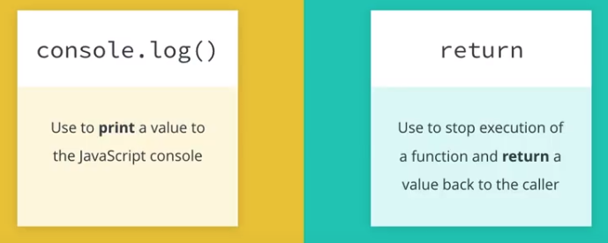
Lesson 14:7 Return Values
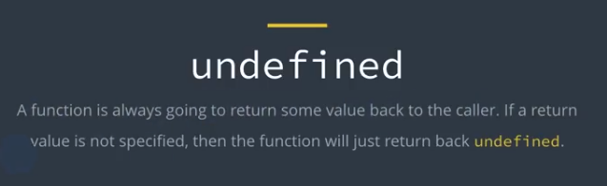

Returning vs. Logging
It’s important to understand that return and print are not the same thing. Printing a value to the JavaScript console only displays a value (that you can view for debugging purposes), but the value it displays can't really be used for anything more than that. For this reason, you should remember to only use console.log to test your code in the JavaScript console.
Paste the following function declaration and function invocation into the JavaScript console to see the difference between logging (printing) and returning:
function isThisWorking(input) {
console.log("Printing: isThisWorking was called and " + input + " was passed in as an argument.");
return "Returning: I am returning this string!";
}

isThisWorking(3);
Prints: "Printing: isThisWorking was called and 3 was passed in as an argument"
Returns: "Returning: I am returning this string!"
If you don't explicitly define a return value, the function will return undefined by default.
function isThisWorking(input) {
console.log("Printing: isThisWorking was called and " + input + " was passed in as an argument.");
}
isThisWorking(3);
Prints: "Printing: isThisWorking was called and 3 was passed in as an argument"
Returns: undefined

14:8 Using Return Values

Using Return Values
Returning a value from a function is great, but what's the use of a return value if you're not going to use the value to do something?
A function's return value can be stored in a variable or reused throughout your program as a function argument. Here, we have a function that adds two numbers together, and another function that divides a number by 2. We can find the average of 5 and 7 by using the add() function to add a pair of numbers together, and then by passing the sum of the two numbers add(5, 7) into the function divideByTwo() as an argument.
And finally, we can even store the final answer in a variable called average and use the variable to perform even more calculations in more places!
// returns the sum of two numbers
function add(x, y) {
return x + y;
}

// returns the value of a number divided by 2
function divideByTwo(num) {
return num / 2;
}

var sum = add(5, 7); // call the "add" function and store the returned value in the "sum" variable
var average = divideByTwo(sum); // call the "divideByTwo" function and store the returned value in the "average" variable

14:12 Global Variables

Using global variables
So you might be wondering:
"Why wouldn't I always use global variables? Then, I would never need to use function arguments since ALL my functions would have access to EVERYTHING!"
Well... Global variables might seem like a convenient idea at first, especially when you're writing small scripts and programs, but there are many reasons why you shouldn't use them unless you have to. For instance, global variables can conflict with other global variables of the same name. Once your programs get larger and larger, it'll get harder and harder to keep track and prevent this from happening.
There are also other reasons you'll learn more about in more advanced courses. But for now, just work on minimizing the use of global variables as much as possible.

14:13 Scope Recap

What you've learned so far:
- If an identifier is declared in global scope, it's available everywhere.
- If an identifier is declared in function scope, it's available in the function it was declared in (even in functions declared inside the function).
- When trying to access an identifier, the JavaScript Engine will first look in the current function. If it doesn't find anything, it will continue to the next outer function to see if it can find the identifier there. It will keep doing this until it reaches the global scope.
- Global identifiers are a bad idea. They can lead to bad variable names, conflicting variable names, and messy code.

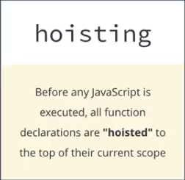
14:14 Hoisting

14:15 Hoisting Recap

What you've learned so far:
- JavaScript hoists function declarations and variable declarations to the top of the current scope.
- Variable assignments are not hoisted.
- Declare functions and variables at the top of your scripts, so the syntax and behavior are consistent with each other.

14:17 – Function Expressions

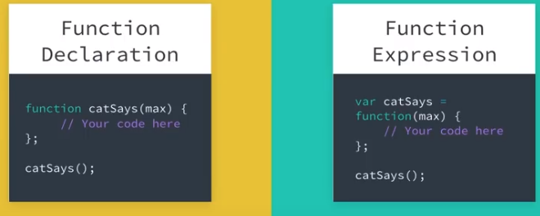
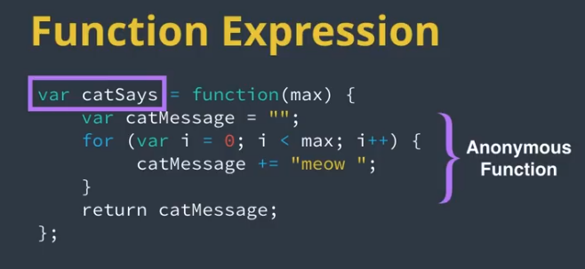

Once you know how to declare a function, a whole new set of possibilities will open up to you.
For instance, remember how you can store anything you want in a variable? Well, in JavaScript, you can also store functions in variables. When a function is stored inside a variable it's called a function expression.
var catSays = function(max) {
var catMessage = "";
for (var i = 0; i < max; i++) {
catMessage += "meow ";
}
return catMessage;
};
Notice how the function keyword no longer has a name.
var catSays = function(max) {
// code here
};
It's an anonymous function, a function with no name, and you've stored it in a variable called catSays.
And, if you try accessing the value of the variable catSays, you'll even see the function returned back to you.
catSays;
Returns:
function(max) {
var catMessage = ""
for (var i = 0; i < max; i++) {
catMessage += "meow ";
}
return catMessage;
}

Function expressions and hoisting
Deciding when to use a function expression and when to use a function declaration can depend on a few things, and you will see some ways to use them in the next section. But, one thing you'll want to be careful of, is hoisting.
All function declarations are hoisted and loaded before the script is actually run. Function expressions are not hoisted, since they involve variable assignment, and only variable declarations are hoisted. The function expression will not be loaded until the interpreter reaches it in the script.

14:18 – Patters with Function Expressions

Functions as parameters
Being able to store a function in a variable makes it really simple to pass the function into another function. A function that is passed into another function is called a callback. Let's say you had a helloCat() function, and you wanted it to return "Hello" followed by a string of "meows" like you had with catSays. Well, rather than redoing all of your hard work, you can make helloCat() accept a callback function, and pass in catSays.
// function expression catSays
var catSays = function(max) {
var catMessage = "";
for (var i = 0; i < max; i++) {
catMessage += "meow ";
}
return catMessage;
};

// function declaration helloCat accepting a callback
function helloCat(callbackFunc) {
return "Hello " + callbackFunc(3);
}

// pass in catSays as a callback function
helloCat(catSays);

Named function expressions

Inline function expressions
A function expression is when a function is assigned to a variable. And, in JavaScript, this can also happen when you pass a function inline as an argument to another function. Take the favoriteMovie example for instance:
// Function expression that assigns the function displayFavorite
// to the variable favoriteMovie
var favoriteMovie = function displayFavorite(movieName) {
console.log("My favorite movie is " + movieName);
};

// Function declaration that has two parameters: a function for displaying
// a message, along with a name of a movie
function movies(messageFunction, name) {
messageFunction(name);
}

// Call the movies function, pass in the favoriteMovie function and name of movie
movies(favoriteMovie, "Finding Nemo");
Returns: My favorite movie is Finding Nemo
But you could have bypassed the first assignment of the function, by passing the function to the movies() function inline.
// Function declaration that takes in two arguments: a function for displaying
// a message, along with a name of a movie
function movies(messageFunction, name) {
messageFunction(name);
}

// Call the movies function, pass in the function and name of movie
movies(function displayFavorite(movieName) {
console.log("My favorite movie is " + movieName);
}, "Finding Nemo");
Returns: My favorite movie is Finding Nemo
This type of syntax, writing function expressions that pass a function into another function inline, is really common in JavaScript. It can be a little tricky at first, but be patient, keep practicing, and you'll start to get the hang of it!

Why use anonymous inline function expressions?
Using an anonymous inline function expression might seem like a very not-useful thing at first. Why define a function that can only be used once and you can't even call it by name?
Anonymous inline function expressions are often used with function callbacks that are probably not going to be reused elsewhere. Yes, you could store the function in a variable, give it a name, and pass it in like you saw in the examples above. However, when you know the function is not going to be reused, it could save you many lines of code to just define it inline.

14:19 – Function Expression Recap

What you've learned so far:
Function Expression: When a function is assigned to a variable. The function can be named, or anonymous. Use the variable name to call a function defined in a function expression.
// anonymous function expression
var doSomething = function(y) {
return y + 1;
};
// named function expression
var doSomething = function addOne(y) {
return y + 1;
};
// for either of the definitions above, call the function like this:
doSomething(5);
Returns: 6
You can even pass a function into another function inline. This pattern is commonly used in JavaScript, and can be helpful streamlining your code.
// function declaration that takes in two arguments: a function for displaying
// a message, along with a name of a movie
function movies(messageFunction, name) {
messageFunction(name);
}

// call the movies function, pass in the function and name of movie
movies(function displayFavorite(movieName) {
console.log("My favorite movie is " + movieName);
}, "Finding Nemo");

15:3 Creating an Array

Arrays
An array is useful because it stores multiple values into a single, organized data structure. You can define a new array by listing values separated with commas between square brackets [].
// creates a `donuts` array with three strings
var donuts = ["glazed", "powdered", "jelly"];
But strings aren’t the only type of data you can store in an array. You can also store numbers, booleans… and really anything!
// creates a `mixedData` array with mixed data types
var mixedData = ["abcd", 1, true, undefined, null, "all the things"];
You can even store an array in an array to create a nested array!
// creates a `arraysInArrays` array with three arrays
var arraysInArrays = [[1, 2, 3], ["Julia", "James"], [true, false, true, false]];
Nested arrays can be particularly hard to read, so it's common to write them on one line, using a newline after each comma:
var arraysInArrays = [
[1, 2, 3],
["Julia", "James"],
[true, false, true, false]
];
Later in this lesson, we’ll look into some unique situations where nested arrays can be useful.
15:5 Array Index

Indexing
Remember that elements in an array are indexed starting at the position 0. To access an element in an array, use the name of the array immediately followed by square brackets containing the index of the value you want to access.
var donuts = ["glazed", "powdered", "sprinkled"];
console.log(donuts[0]); // "glazed" is the first element in the `donuts` array
Prints: "glazed"
One thing to be aware of is if you try to access an element at an index that does not exist, a value of undefined will be returned back.
console.log(donuts[3]); // the fourth element in `donuts` array does not exist!
Prints: undefined
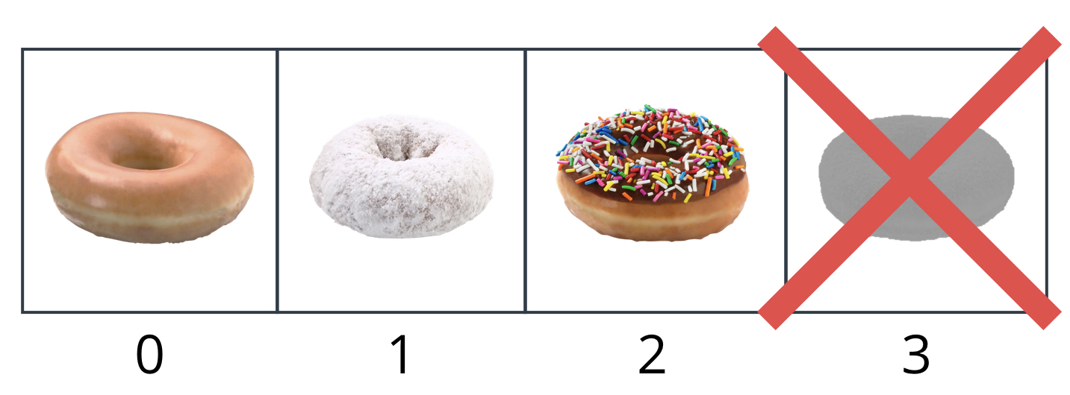
Avoid accessing elements outside the bounds of an array. If you try to, the missing element will be returned back as undefined !
Finally, if you want to change the value of an element in array, you can do so by setting it equal to a new value.
donuts[1] = "glazed cruller"; // changes the second element in the `donuts` array to "glazed cruller"
console.log(donuts[1]);
Prints: "glazed cruller"

15:10 Length

Array.length
You can find the length of an array by using its length property.
var donuts = ["glazed", "powdered", "sprinkled"];
console.log(donuts.length);
Prints: 3
To access the length property, type the name of the array, followed by a period . (you’ll also use the period to access other properties and methods), and the word length. The length property will then return the number of elements in the array.
TIP: Strings have a length property too! You can use it to get the length of any string. For example, "supercalifragilisticexpialidocious".length returns 34.
15.11 Push
So you can find length of an array, but what if you want to modify an array?
Thankfully, arrays have quite a few built-in methods for adding and removing elements from an array. The two most common methods for modifying an array are push() and pop().

Push
You can use the push() method to add elements to the end of an array.
For example, imagine the following spread of donuts.

A spread of donuts. Yummy!
You can represent the spread of donuts using an array.
var donuts = ["glazed", "chocolate frosted", "Boston creme", "glazed cruller", "cinnamon sugar", "sprinkled"];
Then, you can push donuts onto the end of the array using the push() method.
donuts.push("powdered"); // pushes "powdered" onto the end of the `donuts` array
Returns: 7
donuts array: ["glazed", "chocolate frosted", "Boston creme", "glazed cruller", "cinnamon sugar", "sprinkled", "powdered"]

Notice, with the push() method you need to pass the value of the element you want to add to the end of the array. Also, the push() method returns the length of the array after an element has been added.
var donuts = ["glazed", "chocolate frosted", "Boston creme", "glazed cruller", "cinnamon sugar", "sprinkled"];
donuts.push("powdered"); // the `push()` method returns 7 because the `donuts` array now has 7 elements
Returns: 7
15.12 Pop

Pop
Alternatively, you can use the pop() method to remove elements from the end of an array.
var donuts = ["glazed", "chocolate frosted", "Boston creme", "glazed cruller", "cinnamon sugar", "sprinkled", "powdered"];

donuts.pop(); // pops "powdered" off the end of the `donuts` array
donuts.pop(); // pops "sprinkled" off the end of the `donuts` array
donuts.pop(); // pops "cinnamon sugar" off the end of the `donuts` array
Returns: "cinnamon sugar"
donuts array: ["glazed", "chocolate frosted", "Boston creme", "glazed cruller"]
With the pop() method you don’t need to pass a value; instead, pop() will always remove the last element from the end of the array. Also, pop() returns the element that has been removed in case you need to use it.
var donuts = ["glazed", "chocolate frosted", "Boston creme", "glazed cruller", "cinnamon sugar", "sprinkled", "powdered"];
donuts.pop(); // the `pop()` method returns "powdered" because "powdered" was the last element on the end of `donuts` array
Returns: "powdered"

15:13 Splice

Splice
splice() is another handy method that allows you to add and remove elements from anywhere within an array.
While push() and pop() limit you to adding and removing elements from the end of an array, splice()lets you specify the index location to add new elements, as well as the number of elements you'd like to delete (if any).
var donuts = ["glazed", "chocolate frosted", "Boston creme", "glazed cruller"];
donuts.splice(1, 1, "chocolate cruller", "creme de leche"); // removes "chocolate frosted" at index 1 and adds "chocolate cruller" and "creme de leche" starting at index 1
Returns: ["chocolate frosted"]
donuts array: ["glazed", "chocolate cruller", "creme de leche", "Boston creme", "glazed cruller"]
The first argument represents the starting index from where you want to change the array, the second argument represents the numbers of elements you want to remove, and the remaining arguments represent the elements you want to add.
splice() is an incredibly powerful method that allows you to manipulate your arrays in a variety of ways. Any combination of adding or removing elements from an array can all be done in one simple line of code.
Take a look at the MDN documentation to see a long list of example code snippets demonstrating the power of splice() and then try the next set of programming quizzes.

QUIZ QUESTION
We’ve decided to replace some of the donuts in the donuts array.
var donuts = ["cookies", "cinnamon sugar", "creme de leche"];

donuts.splice(-2, 0, "chocolate frosted", "glazed");
What does the donuts array look like after the following changes?
["cookies", "chocolate frosted", "glazed", "cinnamon sugar", "creme de leche"]

15:18 Array Loops

Array Loops
Once the data is in the array, you want to be able to efficiently access and manipulate each element in the array without writing repetitive code for each element.
For instance, if this was our original donuts array:
var donuts = ["jelly donut", "chocolate donut", "glazed donut"];
and we decided to make all the same donut types, but only sell them as donut holes instead, we could write the following code:
donuts[0] += " hole";
donuts[1] += " hole";
donuts[2] += " hole";
donuts array: ["jelly donut hole", "chocolate donut hole", "glazed donut hole"]
But remember, you have another powerful tool at your disposal loops!
To loop through an array, you can use a variable to represent the index in the array, and then loop over that index to perform whatever manipulations your heart desires.
var donuts = ["jelly donut", "chocolate donut", "glazed donut"];

// the variable `i` is used to step through each element in the array
for (var i = 0; i < donuts.length; i++) {
donuts[i] += " hole";
donuts[i] = donuts[i].toUpperCase();
}
donuts array: ["JELLY DONUT HOLE", "CHOCOLATE DONUT HOLE", "GLAZED DONUT HOLE"]
In this example, the variable i is being used to represent the index of the array. As i is incremented, you are stepping over each element in the array starting from 0 until donuts.length - 1 (donuts.length is out of bounds).

15:19

The forEach() loop
Arrays have a set of special methods to help you iterate over and perform operations on collections of data. You can view the MDN Documentation list of Array methods here, but a couple big ones to know are the forEach() and map() methods.
The forEach() method gives you an alternative way to iterate over an array, and manipulate each element in the array with an inline function expression.
var donuts = ["jelly donut", "chocolate donut", "glazed donut"];

donuts.forEach(function(donut) {
donut += " hole";
donut = donut.toUpperCase();
console.log(donut);
});
Prints:
JELLY DONUT HOLE
CHOCOLATE DONUT HOLE
GLAZED DONUT HOLE
Notice that the forEach() method iterates over the array without the need of an explicitly defined index. In the example above, donut corresponds to the element in the array itself. This is different from a for or while loop where an index is used to access each element in the array:
for (var i = 0; i < donuts.length; i++) {
donuts[i] += " hole";
donuts[i] = donuts[i].toUpperCase();
console.log(donuts[i]);
}

Parameters
The function that you pass to the forEach() method can take up to three parameters. In the video, these are called element, index, and array, but you can call them whatever you like.
The forEach() method will call this function once for each element in the array (hence the name forEach.) Each time, it will call the function with different arguments.

The element parameter will get the value of the array element.
The index parameter will get the index of the element (starting with zero). The array parameter will get a reference to the whole array, which is handy if you want to modify the elements.

Here's another example:
words = ["cat", "in", "hat"];
words.forEach(function(word, num, all) {
console.log("Word " + num + " in " + all.toString() + " is " + word);
});
Prints:
Word 0 in cat,in,hat is cat
Word 1 in cat,in,hat is in
Word 2 in cat,in,hat is hat
On the next page, you'll do a quiz that uses the forEach() method to modify an array.

15:21

Using forEach() will not be useful if you want to permanently modify the original array. forEach()always returns undefined. However, creating a new array from an existing array is simple with the powerful map() method.
With the map() method, you can take an array, perform some operation on each element of the array, and return a new array.
var donuts = ["jelly donut", "chocolate donut", "glazed donut"];

var improvedDonuts = donuts.map(function(donut) {
donut += " hole";
donut = donut.toUpperCase();
return donut;
});
donuts array: ["jelly donut", "chocolate donut", "glazed donut"]
improvedDonuts array: ["JELLY DONUT HOLE", "CHOCOLATE DONUT HOLE", "GLAZED DONUT HOLE"]
Oh man, did you just see that? The map() method accepts one argument, a function that will be used to manipulate each element in the array. In the above example, we used a function expression to pass that function into map(). This function is taking in one argument, donut which corresponds to each element in the donuts array. You no longer need to iterate over the indices anymore. map() does all that work for you.

15:24 2D Donut Arrays

2D Donut Arrays

Oftentimes, donuts are arranged in a grid like this:
A box of donuts can resemble a two dimensional grid with rows and columns.
You could use an array of arrays that has the name of each donut associated with its position in the box.
Here's an example:
var donutBox = [
["glazed", "chocolate glazed", "cinnamon"],
["powdered", "sprinkled", "glazed cruller"],
["chocolate cruller", "Boston creme", "creme de leche"]
];
If you wanted to loop over the donut box and display each donut (along with its position in the box!) you would start with writing a for loop to loop over each row of the box of donuts:
var donutBox = [
["glazed", "chocolate glazed", "cinnamon"],
["powdered", "sprinkled", "glazed cruller"],
["chocolate cruller", "Boston creme", "creme de leche"]
];

// here, donutBox.length refers to the number of rows of donuts
for (var row = 0; row < donutBox.length; row++) {
console.log(donutBox[row]);
}
Prints:
["glazed", "chocolate glazed", "cinnamon"]
["powdered", "sprinkled", "glazed cruller"]
["chocolate cruller", "Boston creme", "creme de leche"]
Since each row is an array of donuts, you next need to set up an inner-loop to loop over each cell in the arrays.
for (var row = 0; row < donutBox.length; row++) {
// here, donutBox[row].length refers to the length of the donut array currently being looped over
for (var column = 0; column < donutBox[row].length; column++) {
console.log(donutBox[row][column]);
}
}
Prints:
"glazed"
"chocolate glazed"
"cinnamon"
"powdered"
"sprinkled"
"glazed cruller"
"chocolate cruller"
"Boston creme"
"creme de leche"
In this loop, the outer loop cycles rows and the inner loops cycles through columns.
16:2 Objects in Code

NOTE: typeof is an operator that returns the name of the data type that follows it:
typeof "hello" // returns "string"
typeof true // returns "boolean"
typeof [1, 2, 3] // returns "object" (Arrays are a type of object)
typeof function hello() { } // returns "function"

16:5 Object Literals

Object-literal notation
var sister = {
name: "Sarah",
age: 23,
parents: [ "alice", "andy" ],
siblings: ["julia"],
favoriteColor: "purple",
pets: true
};
The syntax you see above is called object-literal notation. There are some important things you need to remember when you're structuring an object literal:
- The "key" (representing a property or method name) and its "value" are separated from each other by a colon
- The key: value pairs are separated from each other by commas
- The entire object is wrapped inside curly braces { }.
And, kind of like how you can look up a word in the dictionary to find its definition, the key in a key:value pair allows you to look up a piece of information about an object. Here's are a couple examples of how you can retrieve information about my sister's parents using the object you created.
// two equivalent ways to use the key to return its value
sister["parents"] // returns [ "alice", "andy" ]
sister.parents // also returns ["alice", "andy"]
Using sister["parents"] is called bracket notation (because of the brackets!) and using sister.parents is called dot notation (because of the dot!).
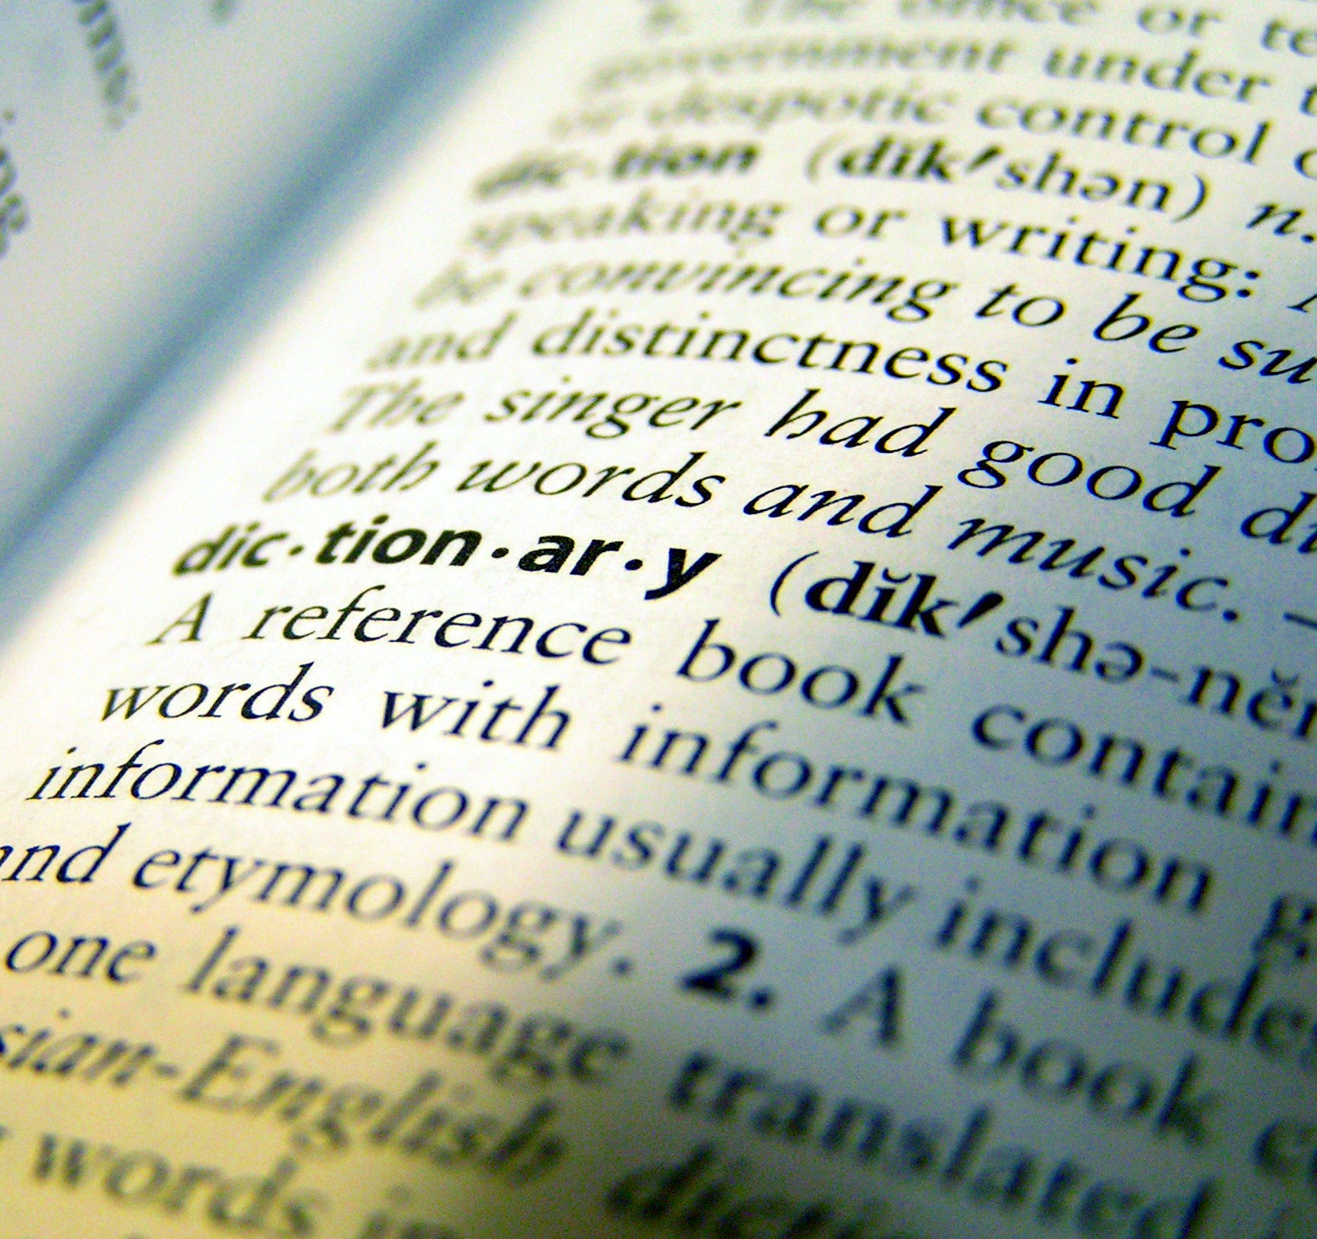Dictionary - Caleb Roenigk - Creative Commons

What about methods?
The sister object above contains a bunch of properties about my sister, but doesn't really say what my sister does. For instance, let's say my sister likes to paint. You might have a paintPicture() method that returns "Sarah paints a picture!" whenever you call it. The syntax for this is pretty much exactly the same as how you defined the properties of the object. The only difference is, the value in the key:value pair will be a function.
var sister = {
name: "Sarah",
age: 23,
parents: [ "alice", "andy" ],
siblings: ["julia"],
favoriteColor: "purple",
pets: true,
paintPicture: function() { return "Sarah paints!"; }
};

sister.paintPicture();
Returns: "Sarah paints!"
and you can access the name of my sister by accessing the name property:
sister.name
Returns: "Sarah"

16:7 Summary of Objects

Objects are one of the most important data structures in JavaScript. Get ready to see them everywhere!
They have properties (information about the object) and methods (functions or capabilities the object has). Objects are an incredibly powerful data type and you will see them all over the place when working with JavaScript, or any other object-oriented programming language.

Object literals, methods, and properties
You can define objects using object-literal notation:
var myObj = {
color: "orange",
shape: "sphere",
type: "food",
eat: function() { return "yummy" }
};

myObj.eat(); // method
myObj.color; // property

Naming conventions
Feel free to use upper and lowercase numbers and letters, but don't start your property name with a number. You don't need to wrap the string in quotes! If it's a multi-word property, use camel case. Don't use hyphens in your property names
var richard = {
"1stSon": true;
"loves-snow": true;
};

richard.1stSon // error
richard.loves-snow // error

